ALCHEMY PVT TUITIONS

Class : XIIth Subject : CHEMISTRY
Date : 01/10/2022 DPP No. : 2
Topic :- Electro Chemistry

1. | In electrolytic purification, which of the following is made of impure metal?
 | a) | Anode | b) | Cathode | c) | Both (a) and (b) | d) | None of these
2. | The specific conductivity of 0.1 N KCl solution is 0.0129 $Ω^{-1}{cm}^{-1}.$ The resistance of the solution in the cell 100Ω. The cell constant of the cell will be
 | a) | 1.10 | b) | 1.29 | c) | 0.56 | d) | 2.80
3. | Which graph correctly correlates $E_{Cell}$ as a function of concentrations for the cell (for different values of M and Mʹ)?  $Zn\left(s\right)+Cu^{2+}\left(M\right)⟶{Zn}^{2+}\left(Mʹ\right)+Cu(s)$;  $E°_{Cell}=1.10 V$  $X-axis : \frac{\left[Zn^{2+}\right]}{\left[Cu^{2+}\right]}, Y-axis :E_{Cell}$
 | a) | 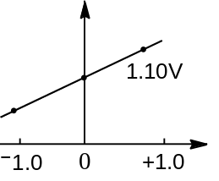 | b) | 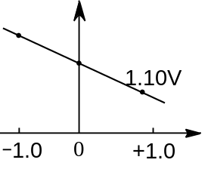 | c) | 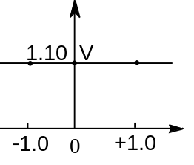 | d) | 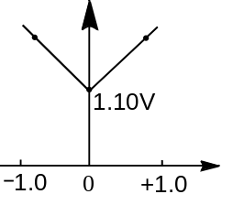
4. | In acidic medium $MnO_{4}^{-}$ is converted to ${Mn}^{2+}$. The quantity of electricity in faraday required to reduce 0.5 mole of $MnO_{4}^{-}$ to ${Mn}^{2+}$ would be
 | a) | 2.5 | b) | 5 | c) | 1 | d) | 0.5
5. | In electrolysis, oxidation takes place at:
 | a) | Anode
 | b) | Cathode
 | c) | The anode as well as cathode
 | d) | The surface of electrolyte solution
6. | A depolariser used in dry cell batteries is :
 | a) | Ammonium chloride | b) | Manganese dioxide | c) | Potassium hydroxide | d) | Sodium phosphate
7. | The $E°_{M^{3+}/M^{2+}}$ values for Cr, Mn, Fe and Co are $-0.41, +1.57, +0.77$and$+1.97 V$ respectively. For which one of these metals, the change in oxidation state from +2 to +3 is easiest?
 | a) | Fe | b) | Mn | c) | Co | d) | Cr
8. | The standard reduction electrode potential values of the elements $A,B$ and $C$ are + 0.68, ⎯2.50 and ⎯ 0.50 V respectively. The order of their reducing power is :
 | a) | $A>B>C$ | b) | $A>C >B$ | c) | $C>B>A$ | d) | $B>C>A$
9. | The number of electrons involved in the reaction when a faraday of electricity is passed through an electrolyte in solution is :
 | a) | $12 ×{10}^{46}$ | b) | 96500 | c) | $8 ×{10}^{16}$ | d) | $6.02 ×{10}^{23}$
10. | The electrolysis of a solution resulted in the formation of $H_{2}$at the cathode and $Cl_{2}$ at the anode. The liquid is:
 | a) | Pure water
 | b) | $H_{2}SO_{4}$ solution
 | c) | $NaCl$ solution in water
 | d) | $CuCl_{2}$ solution in water
11. | The passage of electricity in the Daniell cell when Zn and Cu electrodes are connected:
 | a) | From Cu to Zn inside the cell
 | b) | From Cu to Zn outside the cell
 | c) | From Zn to Cu outside the cell
 | d) | None of the above
12. | $Ni / {Ni}^{2+} [1.0 M] || {Au}^{3+} [1.0 M] / Au$ where $E^{°}$  $for {Ni}^{2+} /Ni is -0.250 V$; and $E^{°}$ for  ${Au}^{3+} / Au$ is 0.150 V. The emf of the cell is
 | a) | +1.25 V | b) | -1.75 V | c) | +1.75 V | d) | +0.4 V
13. | The product obtained at anode when 50% $H_{2}{SO}_{4}$ aqueous solution is electrolysed using platinum electrodes is
 | a) | $H_{2}{SO}_{3}$ | b) | $H_{2}S_{2}O_{8}$ | c) | $O_{2}$ | d) | $H_{2}$
14. | The approximate e.m.f. of a dry cell is :
 | a) | 2.0 V | b) | 1.2 V | c) | 6 V | d) | 1.5 V
15. | $E_{1}, E_{2}$, and $E_{3}$ are the emfs of the following three galvanic cells respectively  - Zn (s) | ${Zn}^{2+}$ (0.1 M) || ${Cu}^{2+}$ (1 M) | Cu (s)  - Zn (s) | ${Zn}^{2+}$ (1 M) || ${Cu}^{2+}$ (1 M) | Cu (s)  - Zn (s) | ${Zn}^{2+}$ (1 M) || ${Cu}^{2+}$ (0.1 M) | Cu (s)  Which one of the following is true?
 | a) | $E_{2}>E_{1}>E_{3}$ | b) | $E_{1}>E_{2}>E_{3}$ | c) | $E_{3}>E_{1}>E_{2}$ | d) | $E_{3}>E_{2}>E_{1}$
16. | The fraction of the total current carried by an ion is known as:
 | a) | Transport number of that ion
 | b) | Conductance of that ion
 | c) | Both(a) and (b)
 | d) | None of the above
17. | In a galvanic cell, which is wrong?
 | a) | Anode has negative polarity
 | b) | Cathode has positive polarity
 | c) | Reduction takes place at anode
 | d) | Reduction takes place at cathode
18. | The rusting of iron takes place as follows  ${2H}^{+} + {2e}^{-} +\frac{1}{2} O_{2} ⟶ H_{2} O \left(l\right);$  $E^{°} = +1.23 V$  ${Fe}^{2+} + {2e}^{-} ⟶ Fe (s); E^{°} = -0.44 V$  Calculate $ΔG°$ for the net process.
 | a) | -322 kJ ${mol}^{-1}$ | b) | -161 kJ ${mol}^{-1}$ | c) | -152 kJ ${mol}^{-1}$ | d) | -76 kJ ${mol}^{-1}$
19. | What weight of copper will be deposited by passing 2 faraday of electricity through a solution of Cu(II) salt?
 | a) | 35.6 g | b) | 63.5 g | c) | 6.35 g | d) | 3.56 g
20. | Chlorine cannot displace :
 | a) | Fluorine from NaF | b) | Iodine from NaI | c) | Bromine from NaBr | d) | None of these

